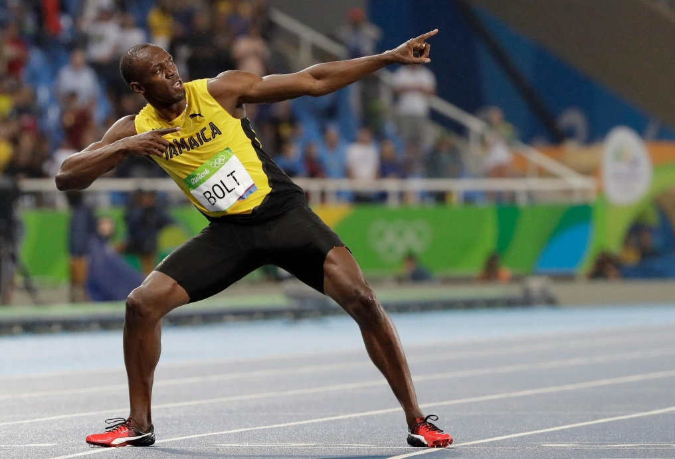
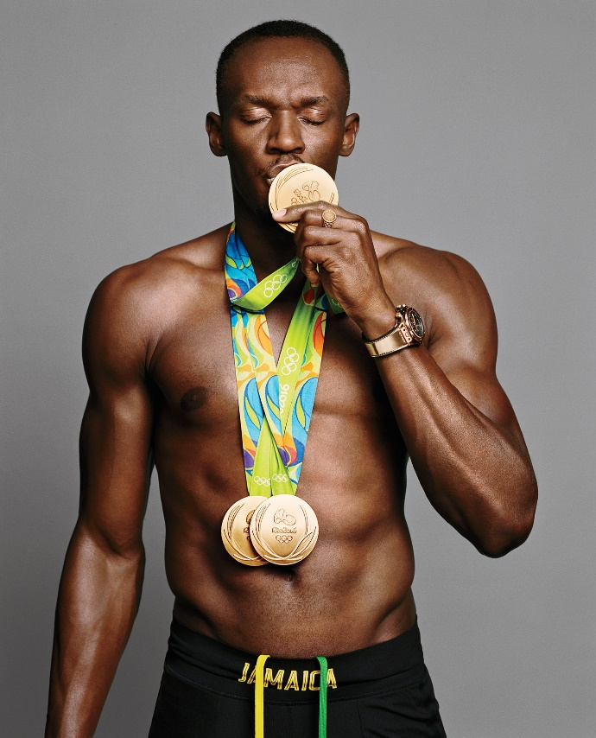

Usain Bolt

Considered to be the greatest sprinter of all time.
Net worth – 90 million
He is a world record holder in the 100 metres, 200 metres and 4 × 100 metres relay.

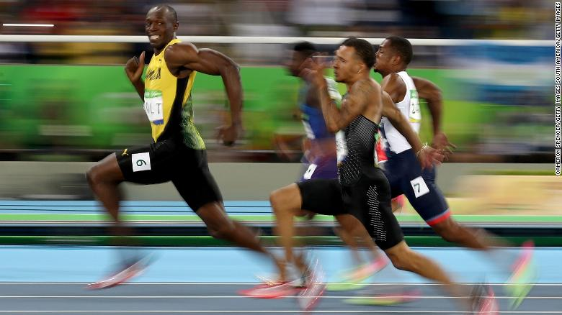


Kim Kardashian
American media personality, socialite, model, businesswoman and producer

Billionaire Businesswomen.

236 million Instagram







KSI
Net worth: 15 million
Youtuber, Boxer and Musician

He started off posting YouTube videos of him playing FIFA
Number 1 Album
36 million YouTube Subscribers KSI didn’t finish School

