Etiquette of Business Activity
Etiquette - Eating out
Student Guidance
The facilitator will have laid out a table for two before you come in. The table will be set up in the following format:
- Wine glasses x 2 (white and red wine glasses – small and bigger)
- Water glass, no stem
- Knife and fork for starter, knife and fork for dinner, spoon and fork for pudding
- Main plate and knife on side plate
- Napkin on the side plate
- Pretend wine bottle (with blackcurrant) and water bottle
- Basket of rolls
- Butter
- Plate with cheese to do a demo – and crackers
Activity Steps
Facilitator to talk to students about how to make a good impression in business and at work.
Show the students how to:
- Use the cutlery – start on the outside and use the cutlery first – ie for starter, then work your way in
- The napkin (if made of cloth then it is called a napkin, if made of paper then it is a serviette)
- To use the napkin, unfold it once and lay on lap and afterwards fold up and put on table next to your plate, never shake it with a flourish or fuss
- Wine glasses – small with stem is white wine, larger glass with stem is normally bigger for red wine
Discuss with students that During dinner…
- Fill wine glass – only fill halfway
- Water glass is next to wine glass (normally no stem)
- Break rolls and put on side plate
- Use side knife which will be on side plate to take the amount of butter you need and put it on the side plate- if no small knife use your main knife.
- Talk in between eating, put knife and fork down from time to time to talk
- Never put your knife in your mouth, don’t put too much food in your mouth
- Use your fork to put your food into your mouth but don’t hold it like a spoon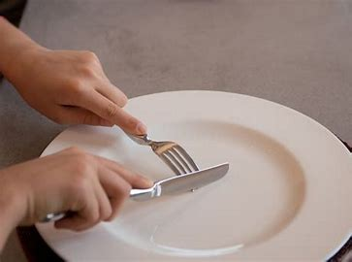
- Don’t talk with mouth full, wait until mouth is empty of food then talk
- If have something you don’t like and have it in your mouth, use your napkin to secretly remove it and put it on your plate
- If have cheese – use side plate. Take a couple of crackers and put on side plate. When cutting cheese cut it as if cutting a piece of cake – follow the line of the cheese – do not cut the pointy bit off. If having butter, take it from the butter dish and put it on your side plate.
Discuss with students that when finishing dinner…
- When finished dinner – put cutlery on plate – side by side at an angle
- When leaving the table, put your napkin (can fold it) put on the table beside your dinner plate (carefully)
- Put your chair under the table
Discuss with students that when at a networking event or at work…
- Listening to what people are saying, makes you stand out
- Remember a person’s name – use tricks – Jack – think of rhyme – ‘Jack and Jill went up the hill’ think Jack - hill
- Before you go to a meeting or networking event think about a couple of things that are in the news – ie just recently an amateur jockey won the grand National at 39 – it was his last race – could then ask if they have ever ridden a horse, have they been to the races
- Make eye contact as you talk to your person
- Ask questions and listen to their reply
- If there is a buffet only put a small amount of food on your plate at a time
- When you want to leave the person you are talking to – just say, do excuse me I am going to talk to …?
- If someone joins you, introduce the person to who you are talking to.
- You don’t have to tell people if you are going to the toilet

