Community analysis: manual

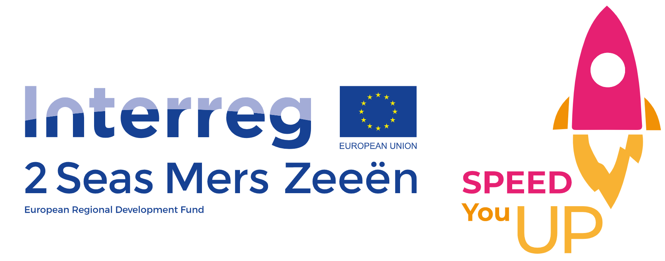

Deliverable
This framework for community analysis was developed as a deliverable for the SYU programme.
The deliverable is described as:
“Framework for the community analysis. A framework for the community analyses will be made by LP, PP4 and PP6. To create community-oriented popups, students will have to do research upon businesses and services in the neighbourhood, needs of the residents. The framework will be based on the Human Centred Design method.” (deliverable D.1.2.1, WP1)
“Develop a framework for community-analysis. Knowing your neighbourhood: active partners will develop (together per 2 seas region) a framework to scan the community. This will enable the coaches to analyse the community in which the NEET young people need to work. This includes a market analysis, building a safe network, scanning for needs within the community and an analysis of the potential location of the pop-up.” (deliverable D.2.3.1, WP2)
Because of the similarity between those two deliverables for both work packages, we have agreed upon making one deliverable (a framework for community analysis) that fits the description for both the work packages.

What is the community analysis framework?
There are different ways to come up with a business idea. Business ideas can be found using different sources: it can be based upon your passions and talents, but some innovative business ideas could also be a potential solution to a problem or a need in the community. To identify those problems or needs in the community, doing a community analysis can be useful.
Also youngsters that have a business idea in mind that still needs refining, can choose to do a community analysis. The community analysis framework consists out of different methods that should help the youngsters to get inspired about what could be beneficial for the community and help them to further work out a more concrete business concept. The community analysis is a tool that can be used to inspire youngsters to come up with a good business idea or to refine the idea they already have. Community analysis can help to identify the needs of the community (what are the complaints in the neighbourhood, what are people missing, what kind of businesses is the community missing…). Youngsters who do not have a business idea yet can use those opportunities as input to think about possible ways to solve those problems and to ease the frustrations in the community. We do not want the youngsters to use the community as a mean to justify their own ideas but really as a source of potential business ideas.
The people from the community will cocreate the businesses together with the youngsters. The community will provide the youngsters with insights into what they think the neighbourhood is lacking. The youngsters will ask feedback of the community. In essence, the products and services will be created based on the insights from the community.

Why youngsters should do the community analysis
We want the youngsters to do a community analysis because of three main reasons.
Firstly, the framework that is developed is based on the human centred design. In human centred design, the focus is on the consumers, the people who will use or buy your product or service. Youngsters have to identify and understand the problems the consumers encounter. By using human centred design for the community analysis, we want the youngsters to focus on the people from the community. It is important that youngsters start their quest for a potential business idea with a profound understanding of the community, the problems of the community and the needs of the community. We don’t want the youngsters to come up with a business idea independently from the community and subsequently impose it on the customer. The customer and his/her needs has to be the starting point, not the product itself. Potential business ideas should emerge from understanding the neighbourhood and truly emphasizing with the people of the neighbourhood and their needs and problems. Therefore, we have chosen different methods that put the consumer/people from the community central. By continuously gathering feedback and asking for input from people from the community, we want the youngsters to stay close to the community and their needs.
Secondly, we want the pop-ups to be community oriented. The communities where we find the NEETs and at-risk NEETs often have multiple problems. We want the youngsters to contribute to the community and think about possible ways to make the community better. We want this project to be beneficial for the youngsters and for the community. By focussing on the community and by making the pop-ups community oriented, we want to distinguish ourselves from other projects. Without doing a community analysis, the pop-ups won’t be community oriented.
Thirdly, we believe that, by doing the community analysis, the youngsters will much easier develop a network. In order to do a community analysis, youngsters will have to get in touch with various people from the community (residents, key figures, entrepreneurs; real estate etc). When youngsters conduct the methods as described below, they will have an extensive network at the end of the community analysis. We believe that this will be beneficial for the potential success of the pop-ups.

How to use the community analysis?
It is advisable that the youngsters do a community analysis. However, they can choose a “light version” of the community analysis or they can go for the extended version and use all the methods available. It is doable to choose just parts of the community analysis as written out here. Youngsters can also approach the community analysis in a way of their own choosing. If they have an own approach, they should verify this with their teacher or coach. If the end goal is reached (understanding the community and the needs of the community), an own approach can be used. Not every possible method is mentioned here so there are definitely some different approaches applicable. We added the “own approach” option in different stages from the framework to stress that it is an option for youngsters to choose their own approach.
Teachers or coaches can also adapt the community analysis framework. They can add or remove methods. It is advisable that the youngsters follow a workshop about the community analysis at the beginning of the SYU trajectory. There they can be given information about the purpose of the community analysis, a brief introduction to design thinking and an explanation about each tool. It is important that the young people, together with their teachers or coaches, select the methods they like the most and find most suiting after following the workshop. Youngsters will follow a skill assessment at the beginning of the SYU trajectory (thus before doing the community analysis). Some methods require different skills from the youngsters, so it is advisable to choose methods that are in line with the skills of the youngsters or are in line with their growth potential. It is advisable that the groups do not split the different methods among themselves, but conduct everything as a group.
We assume youngsters have formed groups already before the community analysis starts (during an earlier module). If multiple groups from one institution work on a community analysis, preferably the results are shared with each other during brief presentations after each module. It is advisable that, at the end of each phase or at a certain point in the programme, youngsters present their insights to the other groups, people from the community and own network (family and friends) during an event. Hereby, the youngsters can benefit from the insights of other groups and it can help in order to motivate them.
The framework for the community analysis is built so that it starts with more general methods, that can give the youngsters a sense of what is positive and negative about their neighbourhood. It ends with methods that are more specific and that are only useful when the youngsters already have worked on their business idea. Because of this structure of the framework, it is advisable that, although youngsters can choose together with their coach and teacher which methods to use, that the sequence of the different methods they select stays the same.
The community analysis is not a phase on its own. The three phases need to be embedded in different modules from the SYU trajectory (see picture below). We have encircled the modules where we think the community analysis fits best.

Framework
The framework consists out of three phases.
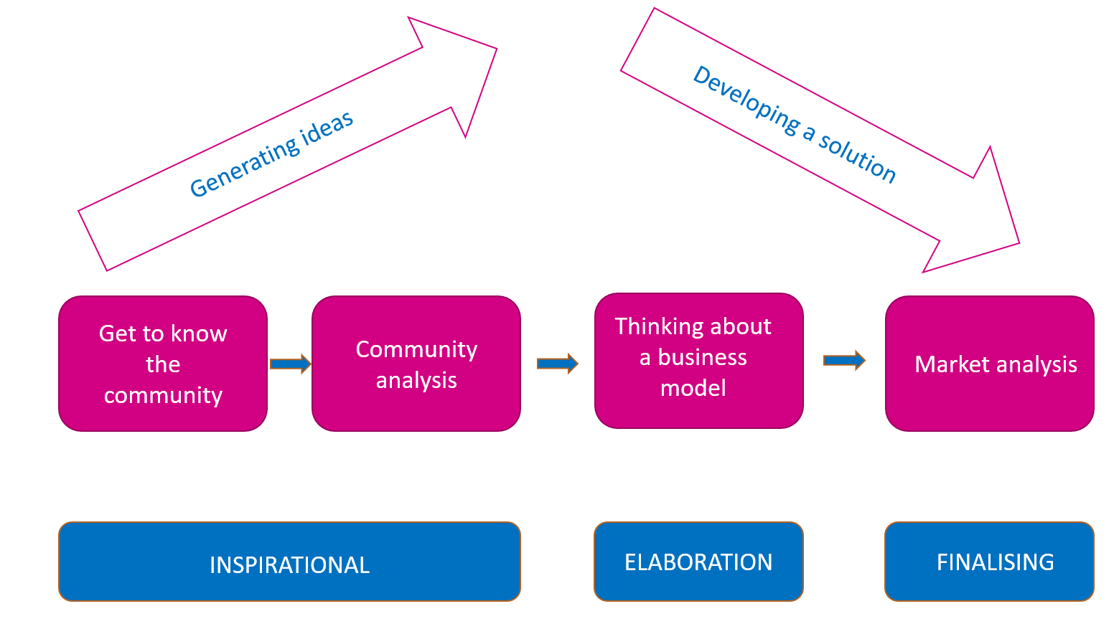
The inspirational phase can take place at the beginning of the SYU project. The objective of this phase is to give the youngsters an in depth understanding of the community and the needs from the people living in the community, to get inspired by potential business ideas and to develop a network with people from the community.
The first part of this phase (‘get to know the community’) consists out of three options. Each option is another approach onto how to become more familiar with the community. For this part, it is advisable that teachers/coaches pick just one option (preferably after consulting the youngsters) and not all three.
The second part of this phase (‘community analysis: mapping the needs of the community’) is the core of the community analysis. Here the youngsters can choose the methods they want to use to research the community. Theoretically, all options can perfectly be executed subsequently but it is not advisable (too time consuming and the added value of doing them all is limited). Every combination of different methods is possible. Every method can be conducted without completing another method. When it is advisable, it is mentioned.
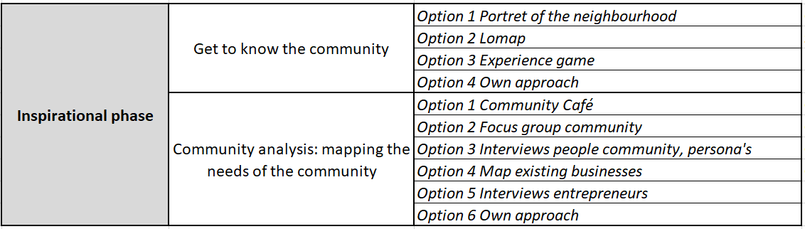
After the first phase youngsters can come up with a business idea. If so, they will enter the next phase, ‘elaboration phase’: thinking about a business model. The objective of this phase is to help youngsters develop a business plan that is community oriented.
The third and final phase (‘finalising phase’: market analysis) should be at the end of the trajectory from SYU. Youngster will need to have some kind of prototype of their product and a clear idea of their business model. They will need to present their ideas to a panel of potential customers/people from the community. Based on the feedback they will receive they can adjust their product, service, or business model. The objective of this phase is to make sure that there is a good match between the product or service, the business model and the community.

The link between the community analysis framework and design thinking
The framework of the community analysis is partially based on design thinking or human centred design. Design thinking focusses on what people actually need. Youngsters need to create businesses that meet the needs of the customers/people living in the community and the product or service must create long-term value for the community and the people living within the community. The idea of design thinking or HCD is that you go to your customers first to determine their needs and then subsequently create a product or service that serves their needs. In design thinking or HCD, a need can be an emotion or a desire that is uncovered during the inspiration phase (the community analysis). Feeling empathy towards the people from the community is crucial. It is really important that the youngsters immerse themselves in the environment of the people from the community, hence the community analysis.
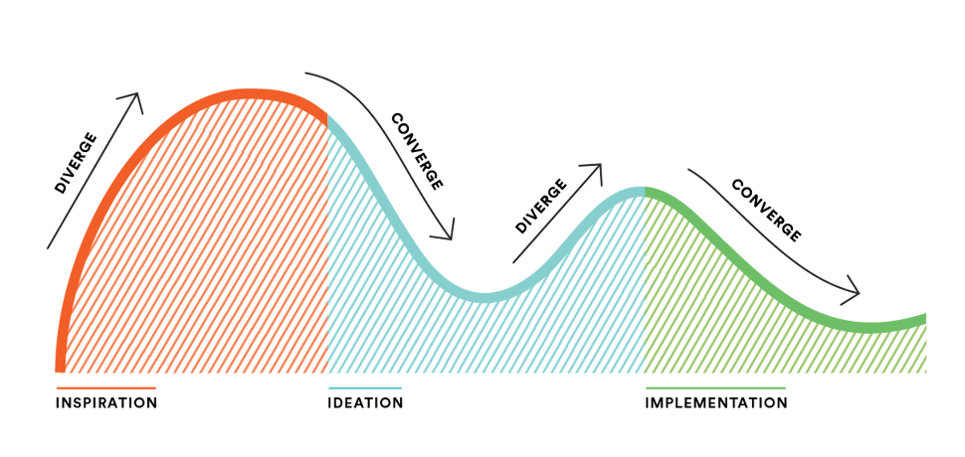
Source: https://www.ideo.org/tools
In the first phase of the community analysis, it is important to get as much inspiration as possible. The youngsters try to identify the needs of the people from the community. The inspiration phase of the community analysis is quite similar to the inspiration phase of the design process. The aim of this phase is to identify the needs and thus getting as much inspiration as possible for potential interesting business ideas.
The ideation phase of the design thinking process is not part of the community analysis. Youngsters can go to their HUBs and work, together with their coach or teacher, on possible solutions for the needs of the people of the community. They select some ideas that they want to develop further. There are tools available that youngsters can use, such as ‘bundle ideas’, ‘create a concept’ or ‘rapid prototyping’ (for more information: see www.designkit.org, ideation). ‘Bundle ideas’ for example is a method youngsters can use in which the best parts of several ideas are bundled together. You do that by clustering similar ideas into groups and subsequently trying to create a solution that combines the best elements you have found. ‘Create a concept’ is a tool they can use after they have ‘bundled ideas’. Here, you can create a concept which is more complete. After you have ‘created a concept’, you can move into ‘rapid prototyping’. Here, you try to make a prototype that is a physical or digital representation of the concept you have in mind. You can use that prototype to gather feedback.
Developing a concept that the youngsters want to develop further is something that they must do themselves, mainly without consulting the people from the community. If possible, it can be an option to cocreate possible solutions in collaboration with people from the community. During this phase: youngsters should also think about a potential business model and a location if applicable (= the elaboration phase of the community analysis).
The final phase of the community analysis is quite similar to the final phase of design thinking. Youngsters have created prototypes that could be a solution to the needs of people of the community. In the third phase (market analysis) youngsters present those prototypes to the community and gather feedback. We want this phase to be a bit broader than in design thinking. Next to gathering feedback on the different prototypes, we want the youngsters to also collect information during the pilots.
We have made a selection of tools that are used in design thinking and implemented other methods in the framework that can be useful for the community analysis but aren’t design thinking (such as LOMAP). Most methods from the community analysis are (partially) based on HCD. There are other tools useable that are not mentioned here. Youngsters (or teachers/coaches) who want to work solely with design thinking can find more methods on www.ideo.org or www.designkit.org. Those websites contain more information about design thinking in general. Other sources are “Entrepreneurship: The Practice ad Mindset” Neck, H., Neck, C., 2017, Inc Sage Publications and “Cecilia’s keuze. Beysen, A., De Lameillieure-Kharatichvili, M., Lernstra, R., Oskamp, J. Ontwerpen met meerwaarde op basis van gebruikersinzichten, 2012, Lannoo” (Dutch).

