Growth Mindset – What do you believe?

- I will learn from feedback
- I will keep trying and never give up
- I will try and believe in myself
- I will learn that mistakes make me grow
- I will try even though I might fail
- I will find out what I did wrong and try again
- I will take on challenges to help me grow
- I will believe that there is always a plan B
- I will believe that Effort will make me stronger
- I will now tell myself that ‘I know this will help me even if it is difficult’
- I will see myself doing things in a positive way
- I will trust my own decisions

I don’t believe this…

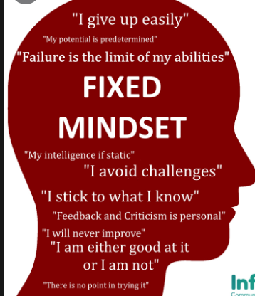

I believe this!

