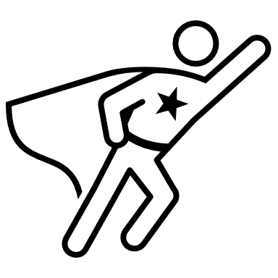


How to build confidence!

Teenage years are not easy! Because of new social changes since the pandemic and changes in the body, teenagers tend to have low self-worth and are full of self-doubt.

What happens then?
This makes teenagers seek approval from both adults and friends and other people their age. Lack of self-esteem can lead to underperforming in social situations and that can have a lasting effect on YOUR future life.

Can this be changed?
YES! It is important to boost your own confidence and self-esteem to ensure that YOU are confident enough to make YOUR own decisions. To choose what’s best for YOU without worrying about what others might think.

About Me
This activity will help you build your confidence because it helps you know the real you, it will help you gain a clearer picture of how you think and feel. This will help build the foundations for your future personality.

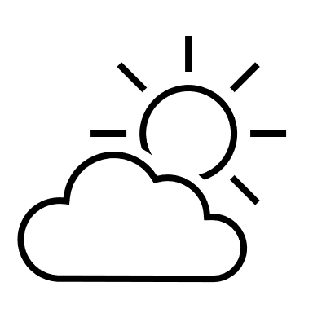
Complete the sentences below…
My two favourite months of the year are_______________.and during these months, I like to ______________________________________________.

Tick one of the options to finish the following sentences (you can pick 2): …
At 18, if I was to go on a special holiday I would want to be based in…
A city
A town
The countryside
By the sea
In the mountains
At sea
The type of holiday I would like to go on is…
Going abroad
This country
Hotel, luxury- all inclusive
Find my own places to stay and arrange my own flights
Staying in two different places over two weeks
Camping, caravan
Self-catering accommodation
A spa, fitness centre
A working holiday – ie learn a new skill (For example, photography)

 Personal Me. Complete the sentences below.
I like myself because_________________________________________________
My favourite place is_________________________________________________
I enjoy_____________________________________________________________
I feel peaceful and calm when__________________________________________
The person I admire the most is____________ because______________________
When I leave school I want to__________________________________________
My friends like this about me___________________________________________
My favourite thing to do when I was young was __________________________________________________________________
My favourite thing to do now is ________________________________________
What could you contribute to the world that would make you feel proud and content?
________________________________________________________________

